User Acceptance Testing (UAT) Documentation
AI FAQ – Intelligent Frequently Asked Questions
Date | 24-09-2026
Team ID | SWTID-2026-1780
Project Name | AI FAQ – Intelligent Frequently Asked Questions
Maximum Marks | 4 Marks
Project Overview
Project Name: AI FAQ – Intelligent Frequently Asked Questions
Project Description: An AI-assisted FAQ system that understands natural-language user questions and provides concise answers from an approved FAQ/knowledge base.
Project Version: 1.0
Testing Period: ________________ to ________________
Testing Scope
- FAQ question input and submission.
- Intent detection for differently worded user questions.
- Search/retrieval from the approved FAQ or knowledge base.
- Generation/display of a clear answer based on trusted FAQ content.
- Clarification and fallback support when no suitable answer is available.
- User feedback such as Helpful / Not Helpful.
- FAQ content updates and consistency of answers.
Testing Environment
URL / Location: AI FAQ application / prototype URL: ______________________________
Credentials: Not required / ______________________________
Browser / Device: Chrome / Android or Desktop: ______________________________
AI FAQ Content
FAQ | Answer
What is the AI FAQ? | An AI-powered FAQ system that understands user questions and provides answers from an approved knowledge base.
How does it work? | The user submits a question. The system detects the intent, searches the FAQ content, and returns the most relevant answer.
What if the question is unclear? | The system can ask the user to clarify the question before providing an answer.
What if there is no matching answer? | The system provides a safe fallback message and can direct the user to human support or the appropriate resource.
Can the FAQ be updated? | Yes. New questions and approved answers can be added to the knowledge base as requirements change.
How is answer quality improved? | User feedback and regular review of unanswered or poorly answered questions can be used to improve the FAQ content.
AI FAQ Flow Diagram
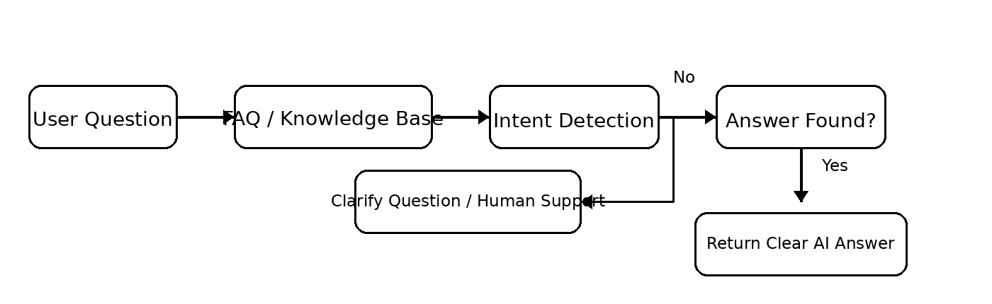
Flow: User Question → FAQ / Knowledge Base → Intent Detection → Answer / Fallback Support
Test Cases
Test Case ID | Test Scenario | Test Steps | Expected Result | Actual Result | Pass/Fail
TC-001 | Submit a common FAQ question | 1. Open AI FAQ  2. Enter a known FAQ question  3. Submit | Relevant approved answer is displayed. | ________________ | ________
TC-002 | Natural-language / rephrased question | 1. Enter the same intent using different wording  2. Submit | System identifies the intent and returns the relevant answer. | ________________ | ________
TC-003 | Unclear question | 1. Enter an incomplete or ambiguous question  2. Submit | System asks for clarification or provides a guided response. | ________________ | ________
TC-004 | No matching FAQ | 1. Enter a question outside the knowledge base  2. Submit | System gives a safe fallback and/or support direction instead of inventing an answer. | ________________ | ________
TC-005 | FAQ knowledge-base update | 1. Add/update an approved FAQ  2. Ask the updated question | Updated answer is available and consistent with the approved content. | ________________ | ________
TC-006 | User feedback | 1. Receive an answer  2. Select Helpful / Not Helpful | Feedback is captured successfully. | ________________ | ________
Bug Tracking
Bug ID | Bug Description | Steps to Reproduce | Severity | Status | Additional Feedback
BG-001 | ________________ | 1. ______________  2. ______________  3. ______________ | Low / Medium / High | Open / In Progress / Closed | ________________
BG-002 | ________________ | 1. ______________  2. ______________  3. ______________ | Low / Medium / High | Open / In Progress / Closed | ________________
Sign-off
Tester Name: ____________________________________________
Date: ____________________________________________
Signature: ____________________________________________
Project Manager Approval: ____________________________________________
Product Owner Approval: ____________________________________________
Notes
- Ensure that all test cases cover both positive and negative scenarios.
- Verify that AI answers are based on approved FAQ/knowledge-base content.
- Check that unclear or unsupported questions follow the defined fallback path.
- Record detailed feedback and any suggestions for improving FAQ quality.
- Obtain sign-off from the project manager and product owner before deployment.

